Automated Locker User Manual

Alden School District

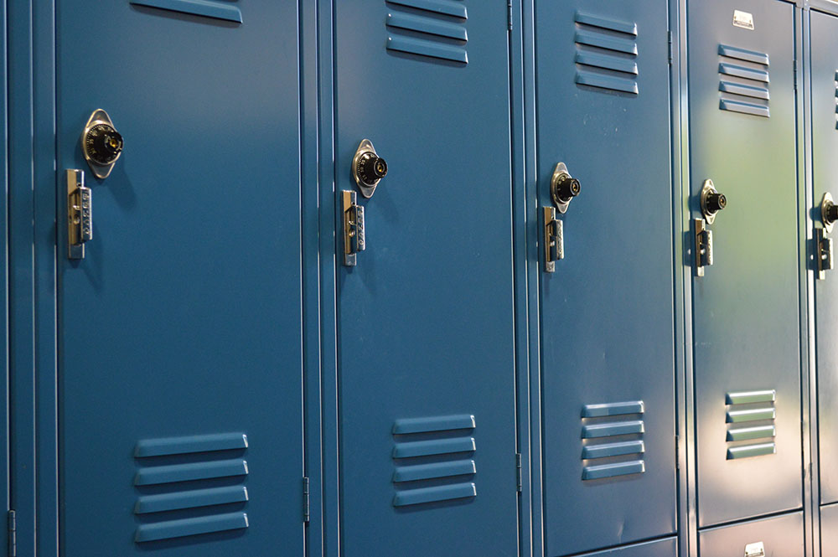

Contents

**Components of the Automated Locker** **3**

Outside the Locker 3

Inside the Locker 4

**Locker Operation** **5**

How to unlock using the touchscreen 5

How to lock using the touchscreen 5

How to change password on locker 5

How to change the battery: The battery should last roughly one school month given 10 openings per day with 1 minute of screen on-time per use. 6

How to charge the battery: 6

How to unlock using manual override: 6

Maintenance 6

**Warnings** **7**

**Troubleshooting** **7**

**Disclaimer** **8**

# 

# Components of the Automated Locker

## Outside the Locker

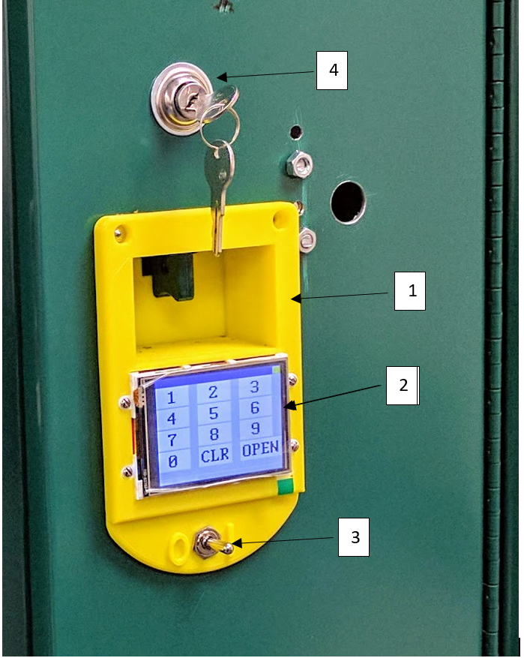

1. 3D printed front plate

2. Screen

3. Power switch

4. Manual override

## Inside the Locker

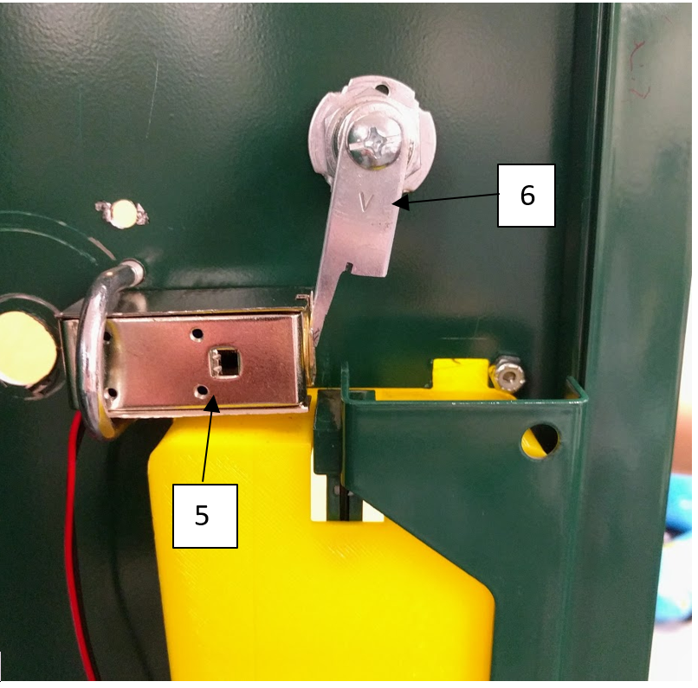

5. Solenoid Lock

6. Manual Override

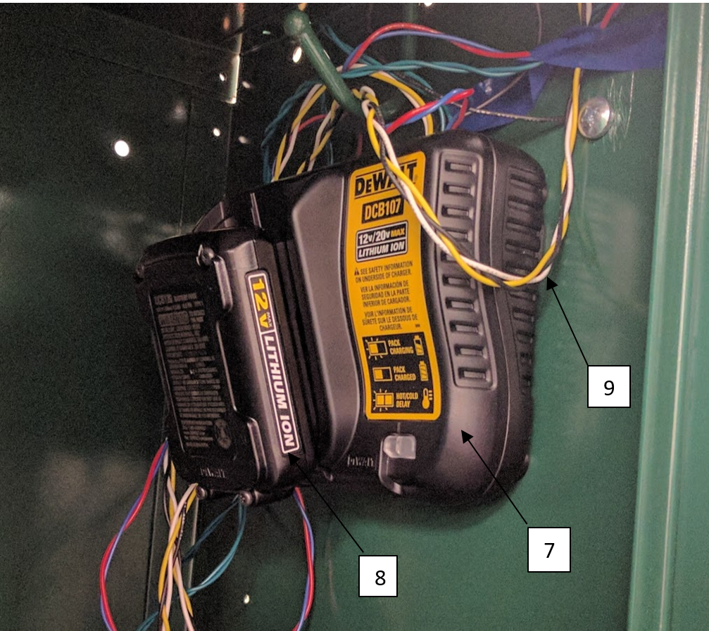

7. Circuit Enclosure

8. Battery

9. Wires

# Locker Operation

## How to unlock using the touchscreen

1. Flip the power switch to ON (1).
2. Enter the number combination (maximum 4 digits).
3. Press “OPEN” and open the locker normally.

## How to lock using the touchscreen

1. The lockers at Alden High School can be closed without unlocking the solenoid again.
2. Close the locker as normal and turn off the touchscreen by flipping the power switch to OFF (0).

If the lockers do not close without unlocking the solenoid:

1. After the password has been entered and the locker has been opened, the screen allows the user to unlock the solenoid without typing the password again (assuming the screen was not turned off. If the screen has been turned off then you will need to re-enter the password to lock the locker).
2. To close the locker, press the “OPEN” button on the screen to unlock the solenoid and allow the latch to be lifted.
3. After closing the locker, turn the touchscreen off by flipping the power switch to OFF (0).

## How to change password on locker

1. Turn the power switch to ON (1).
2. Press the yellow “-” button on top right corner of the touchscreen
3. Type admin password (0258)
4. Press “OPEN”
5. Type new locker password (up to 4 digits)
6. Press “OPEN”
7. Retype new password
8. Press “OPEN”
9. Restart the touchscreen by flipping the power switch to OFF (0) then back to ON (1).

*if you type the wrong admin password, or two new passwords that don’t match, just turn the screen off and on again and restart the process

*REMINDER: Turn off the screen after each use or the battery will be drained very quickly.

## How to change the battery: The battery should last roughly one school month given 10 openings per day with 1 minute of screen on-time per use.

1. Turn off power to locker
2. Remove battery from circuit enclosure
3. Place new battery in enclosure. It will click when seated.
4. Place dead/diminished battery on charger

## How to charge the battery:

1. Plug charger into an appropriate outlet before inserting battery pack
2. Place battery on charger by sliding battery pack onto charging station. A red light will blink to indicate that charging is in progress.
3. The red light will remain on when the battery is fully charged.

## How to unlock using manual override:

1. Insert key into key slot on locker door
2. Turn key counterclockwise and hold in position
3. Open locker with handle as normal

## Maintenance

The only required maintenance for the locker is to make sure the battery remains charged. Please refer to the “How to change the battery” section for details on charging battery packs. If you are unable to open the locker due to a dead battery, use the manual override. Details on how to do so are found in the “How to unlock using manual override” section. If anything else goes wrong with the locker (a battery pack fails, the screen or circuit fails, etc.), please do not attempt to service the product. Contact the State University of New York at Buffalo for assistance.

# 

# Warnings

## To reduce risk of injury, all users must read this User Manual. This device contains sensitive electrical equipment. Do not slam the locker shut, as internal components may shift, causing failure. Avoid exposure to excess moisture and fluids, as this may cause malfunctions or create shock, fire, or other hazards. If a component does get wet, do not turn the product on. Only use approved DeWalt batteries with the DeWalt battery charger, as other types of batteries may burst, causing personal injury and damage. It is possible for the charger to be shorted by foreign material. Do not leave the charger plugged in when there is not battery pack in the charging cavity. When unplugging charger, pull from the plug as opposed to the cord. Do not store or operate batteries or charging station in temperatures that exceed 105°F. When operating the touchscreen, avoid using excess force as it may cause lasting damage. Do not attempt to modify any components of the automated locker.

## Troubleshooting:

No power: dead battery, toggle switch in OFF(0) position - else, damage to components and/or wiring.

Password accepted, but can’t hear solenoid unlocking: solenoid is jammed shut. Forcibly open locker and remove jamming material(s).

Can hear solenoid unlocking, but locker won’t open: locker is jammed shut. Forcibly open locker and remove jamming material(s).

## 

## 

## Disclaimer:

1. The State University of New York at Buffalo and its students/staff assume no liability as a result of their products’ use or application.
2. The State University of New York at Buffalo and its students/staff have used reasonable care in preparing the information included in this document, but do not warrant that such information is error free. The State University of New York at Buffalo and its students/staff assume no liability whatsoever for any damages incurred by you resulting from errors in or omissions from the information included herein.
3. The State University of New York at Buffalo and its students/staff do not assume any liability for infringement of patents, copyrights, or other intellectual property rights of third parties by or arising from the use of The State University of New York at Buffalo and its students/staff’s products or technical information described in this document. No license, express, implied or otherwise, is granted hereby under any patents, copyrights or other intellectual property rights of The State University of New York at Buffalo and its students/staff or others.
4. You should not alter, modify, copy, or otherwise misappropriate any State University of New York at Buffalo product, whether in whole or in part. The State University of New York at Buffalo and its students/staff assume no responsibility for any losses incurred by you or third parties arising from such alteration, modification, copy or otherwise misappropriation of State University of New York at Buffalo products.
5. The State University of New York at Buffalo products and technology may not be used for or incorporated into any products or systems whose manufacture, use, or sale is prohibited under any applicable domestic or foreign laws or regulations.